Council of International Fellowship in Deutschland e. V.

Verein zur Förderung des internationalen Austausches von Fachkräften in der Sozialen Arbeit

CIF-Conference 2023 – Hannover, Germany

POST CONFERENCE TOURS

General information:

- All tours depart from the main train station in Hannover at 10 am on Saturday, June 17^{th,} 2023.
- Transportation will be by train to the named destinations.
- The accommodation will be in single or double rooms in ** and *** -star hotels.
- The size of the groups will be 20 to 30 people.
- If there are not enough registrations, a tour maybe cancelled. In that case you can switch to a different post conference tour.
- The cost for the tours will vary from 320 to 495 Euro, depending on the destination and whether a single or double room is chosen.
- No cancellation policy will apply - The registration is binding, a cancellation is not possible.
- If you would like to find someone to share a double room, please contact conference2023@cif-germany.de and we will try to find you a roommate.
- Included in the price are accommodation, breakfasts, guided tours, and public transportation.
- The tours will end at your destination hotel after breakfast on Tuesday, June 20^{th,} 2023.
- If you would like to return to Hannover, we will help with the needed arrangements.
- The registration deadline for all post conference tours is March1st 2023.
- Payment is to be made after receiving the confirmation in the beginning of March.
- We recommend a travel (cancellation) insurance.

Post-Tour 1: Hamburg

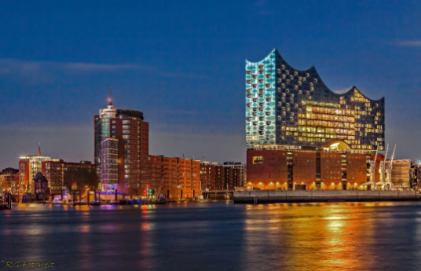

- Travel time from Hannover to Hamburg approx. 2 hours
- Accommodation in the heart of Hamburg at the famous „Reeperbahn“
- Highlights: Habour Boat Tour, Elb-Philharmonie, Harbour City, Old Town, “Schanzenviertel”
- Costs: Single Room 495 € / Double Room 395 € each person

Post-Tour 2: Berlin

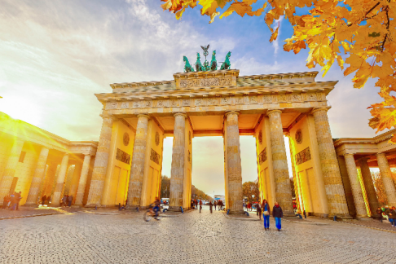

- Travel time from Hannover to Berlin approx. 3 hours
- Highlights: Boat Trip on the Spree River, Reichstag building, Brandenburg Gate, Berlin Wall, Memorial to the Murdered Jews of Europe - Holocaust Memorial, bus-tour
- Costs: Single Room 495 € / Double Room 395 € each person

Post-Tour 3: “Hansa Cities“ - Lübeck and Wismar

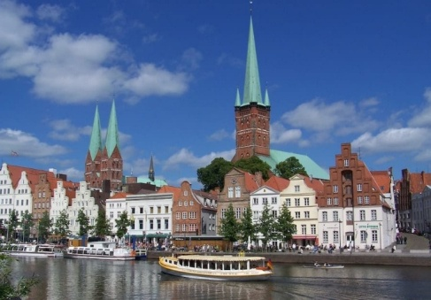

- Travel time from Hannover to Lübeck approx. 2,5 hours
- Highlights: Lübeck’s famous landmark “Holsten Gate“, medieval heart of Lübeck’s Old Town as a World Heritage Site with three gothic brick churches and a historical Town Hall, International Museum of the Hansa (optional)
trip to Wismar, one of the best-preserved medieval town centers in Germany, World Heritage, City of the Hanseatic league, old town with monumental brick churches and an impressive market square, harbour trip
- Costs: Single Room 420 € / Double Room 320 € each person

Post Conference Tour Registration

Please fill in the information requested below and return it until March 1st 2023 to conference2023@cif-germany.de
After that date you will receive an obligatory payment request.

Mr. ☐ Ms. ☐
First Name | enter text here
Last Name | enter text here

☐ I agree to the posttour registration conditions

I register for the following tour:

☐ | Post-Tour 1: Hamburg
☐ | Post-Tour 2: Berlin
☐ | Post-Tour 3: “Hansa Cities” - Lübeck and Wismar

☐ | single room
☐ | double room with: | enter text here
☐ | Double room together with any fellow participant

